Displaying and Comparing Quantitative data

Displaying quantitative data with graphs

Representing data
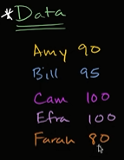
Data is just recorded information.
It could be quantitative represented by a number
You could also rate data based on how they like the test.
I really liked it, I kind of liked it, I don’t like it

table , Bargraph or histogram
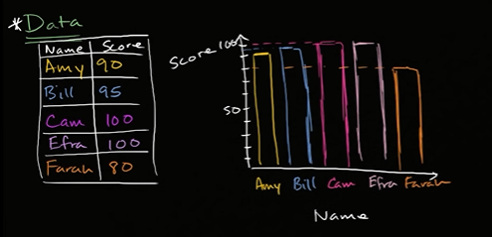

Below one is called frequency plot
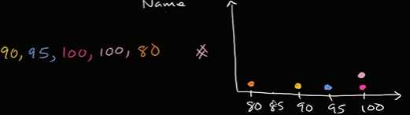

Range is the spread between the highest and lowest point
100-80=20

Frequency tables and Dot plots

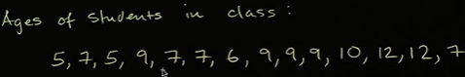

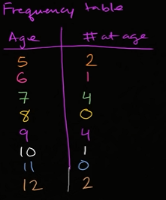
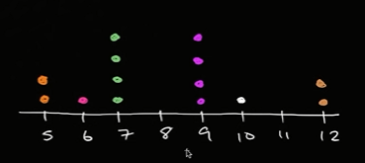

Creating a histogram
So at a restaurant, you wanna see what are the make up of the ages at the restaurant.
So you are interested in somehow visualizing the distribution of the ages.
Cuz u wanna ans: r there more young ppl, r there more older ppl, r there more middle-aged people.
One way is to put these ages into different buckets and how many people are there in each of those buckets.
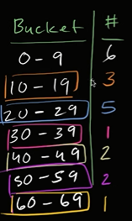
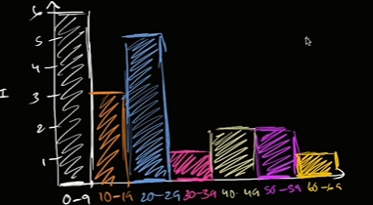

Interpreting a histogram
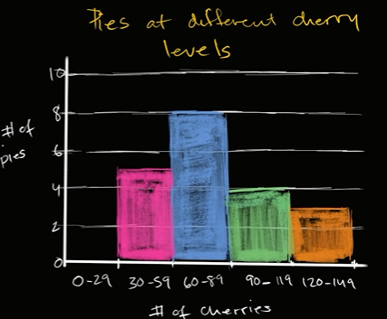
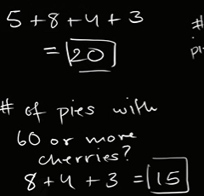

Steam-and-leaf plot
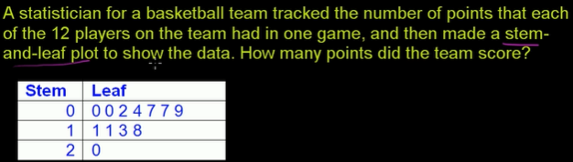
Leaf contains the smallest digit or the one’s digit in the no of points each player scored.
The stem contains the tens digit, usually the leaf will contain the rightmost digit or ones digit and stem will contain all of the other digits.
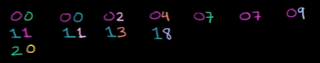

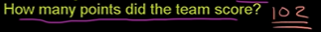

Reading stem and leaf plot
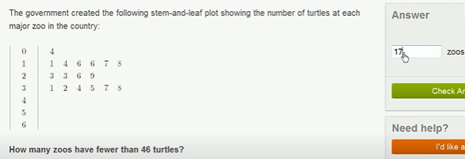
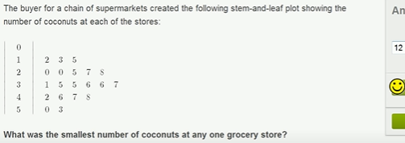

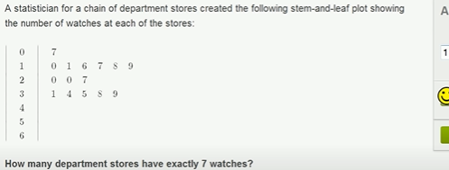

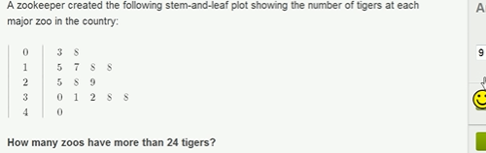

Describing and Comparing distributions

Shape of distributions
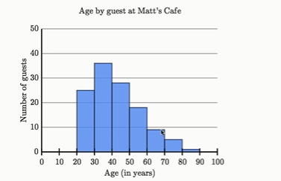

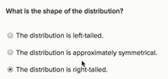
right tailed cuz its the slimmest at the rightmost.

If u r right tailed and left tailed u r approximately symmetrical.
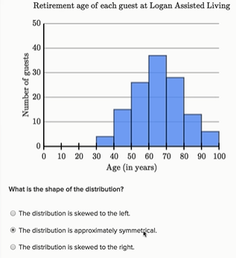
If u draw a line of symmetry, u can see every point in left side is roughly close to the right side.

Easier definition by sal for bignners , So when u have left -tailed u r also tend to skewed to the left

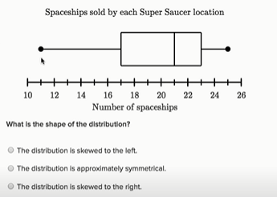
Box plot or whisker plot

Sal said, in the box plot the box defines the middle 50% of our numbers.
Above 21 is the median.
In the entire box plot, the median is close to the right end.
Less value median greater value.
Median is the middle value or finger.
Since its very close to right end.
Which tell data is more skewed towards right or its a left-tailed distribution.
Every points ahead of 21 which is our median that tells the 50% of next datapoints are between 21 and 26.
Median between 21 and 26
tells the distribution is symmetrical.
Considering Here if we draw frequency plot
Median between 10 and 21
tells the distribution is left-tailed or very very roughly symmetrical.
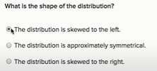

Clusters, gaps, peaks and Outliers
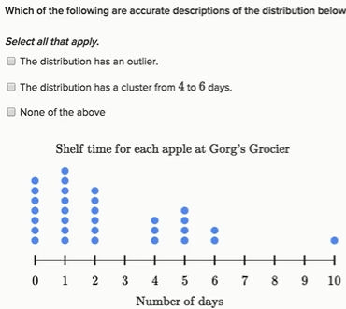
Outlier is a datapoint which is way off from where the other data points are seems to be cluster.

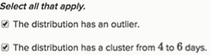

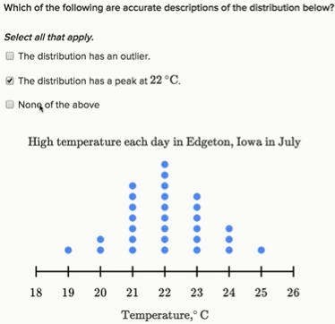

Comparing distributions with dot plots
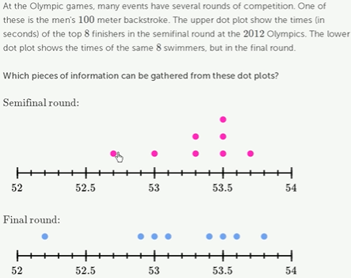

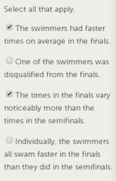

Comparing dot plots, histogram and box plots
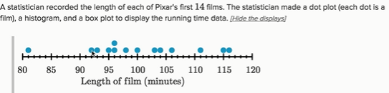

→ Above, You can find median
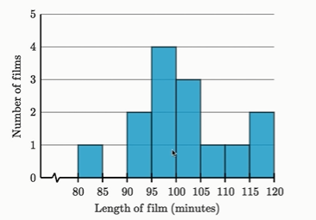

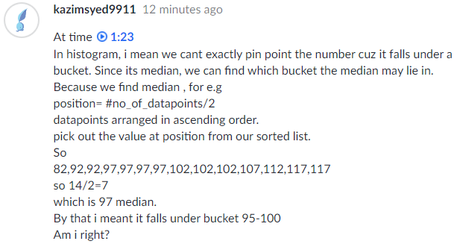

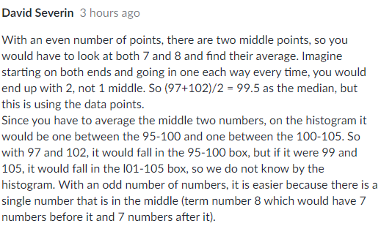

For odd no of datapoints, it seems like svm

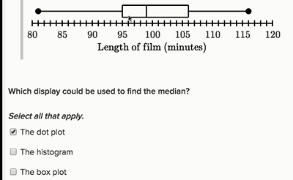

Box plot, frequency plot can be used to find median.
For what box plot lacks?
Question: no of vechiles that have travelled distance greater than 200?
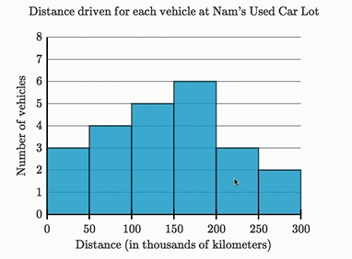

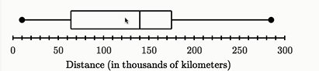

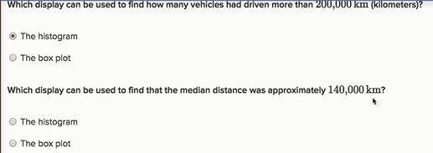

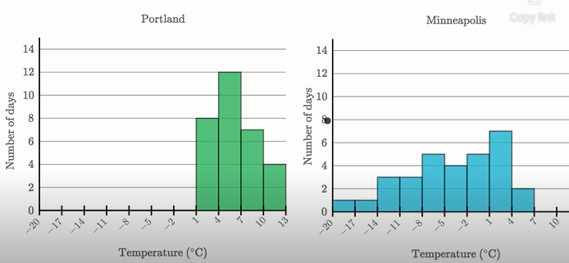
Comparing distribution
When we make this comparision, we look for
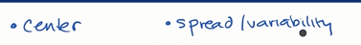

We wanna eyeball it, instead of using mean,median,mode to calc Center
instead of using Range, interquartile range, mean absolute deviation, standard deviation. This all are measures.
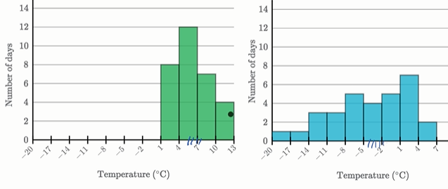

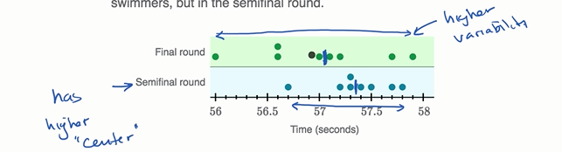
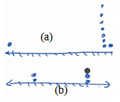
(a) has bigger range and low standard deviation

(b) has lower range but higher standard deviation

More on Data analysis

Reading line graphs
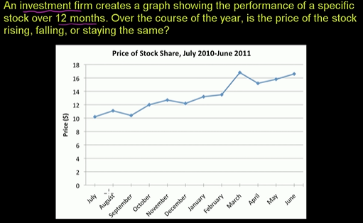

Misleading line graphs

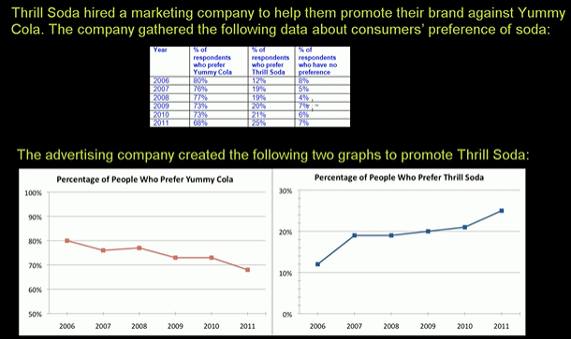
Line graph is used to visualize declining or elevating trend
Here what is misleading is the y axis.
